AUTOMATING EMPLOYEE DATA
USER STORY
The Automating Employee Data project focuses on improving the efficiency of managing employee information within an organization by using the ServiceNow platform. In many organizations, employee data such as personal details, department information, job role, and contact details are often maintained manually or in separate systems. This manual process can lead to errors, duplication of records, difficulty in retrieving information, and delays in administrative tasks.
In this project, the primary user of the system is the Human Resources (HR) administrator, who is responsible for managing employee records. As an HR administrator, the user needs a system that allows them to easily add, update, view, and manage employee information in a centralized platform. The system should provide user-friendly forms where employee details such as employee ID, name, department, designation, email, and contact number can be entered and stored securely.

1.INTRODUCTION
1.1Project overview:
The Automating Employee Data project is designed to simplify and improve the process of managing employee information within an organization. In many companies, employee data such as personal details, department information, job roles, and contact details are often handled manually or stored in different systems. This can lead to data duplication, errors, and delays in accessing important information. The main view of this project is to create a centralized and automated system using the ServiceNow platform where all employee details can be managed efficiently. By implementing automation, the system reduces manual work and ensures that employee information is stored accurately and securely.
Through this system, HR administrators and authorized users can easily add, update, and retrieve employee records through a user-friendly interface. The platform also supports automated workflows that trigger specific actions when employee data is created or modified. This helps in improving the speed and accuracy of HR operations while maintaining proper data management. Overall, the project provides a reliable solution for organizations to manage employee data effectively and enhances productivity by streamlining employee information management processes.

1.2 Purpose :
- To develop an automated system for managing employee data efficiently using the ServiceNow platform.
- To reduce manual work and human errors in employee data entry and management processes.
- To store employee information in a centralized database for easy access and better data organization.
- To improve the accuracy and security of employee records through automated workflows and validations.
- To enhance the efficiency of HR operations by enabling quick retrieval, updating, and reporting of employee data.
2. IDEATION PHASE
2.1Problem Statement

In many organizations, employee data is often managed manually using spreadsheets or paper-based records. This manual method makes it difficult to maintain accurate and updated employee information. HR administrators face challenges in tracking employee details such as personal information, department data, job roles, and contact information. As the number of employees increases, managing this data becomes more complex and time-consuming.
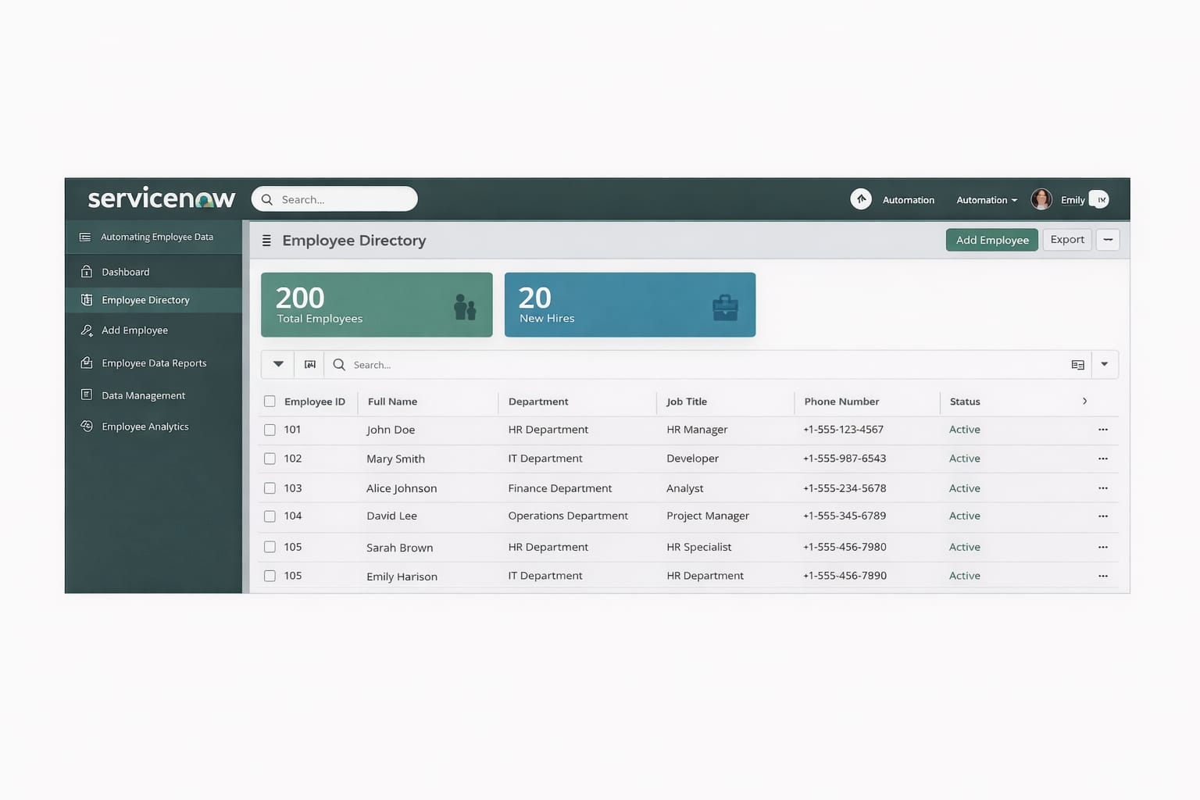
The lack of a centralized system also leads to problems such as data duplication, errors in records, and difficulty in retrieving information when needed. These issues reduce the efficiency of HR operations and may affect organizational productivity. Therefore, there is a need for an automated system that can efficiently store, manage, and update employee data. The Automating Employee Data project aims to solve these problems by developing a centralized and automated platform using ServiceNow to improve the accuracy, security, and accessibility of employee information.
2.2 Empathy Map Canvas
Target Users
● HR Administrators
● HR Managers
● System Administrators
● Organization Managers

Empathy Analysis:
Aspect — Description
● Think & Feel: Need accurate employee information and a reliable system to manage employee records efficiently.
● Hear: Feedback from management about maintaining proper employee data and improving HR operations.
● See: Multiple spreadsheets, files, and manual records used for storing employee information.
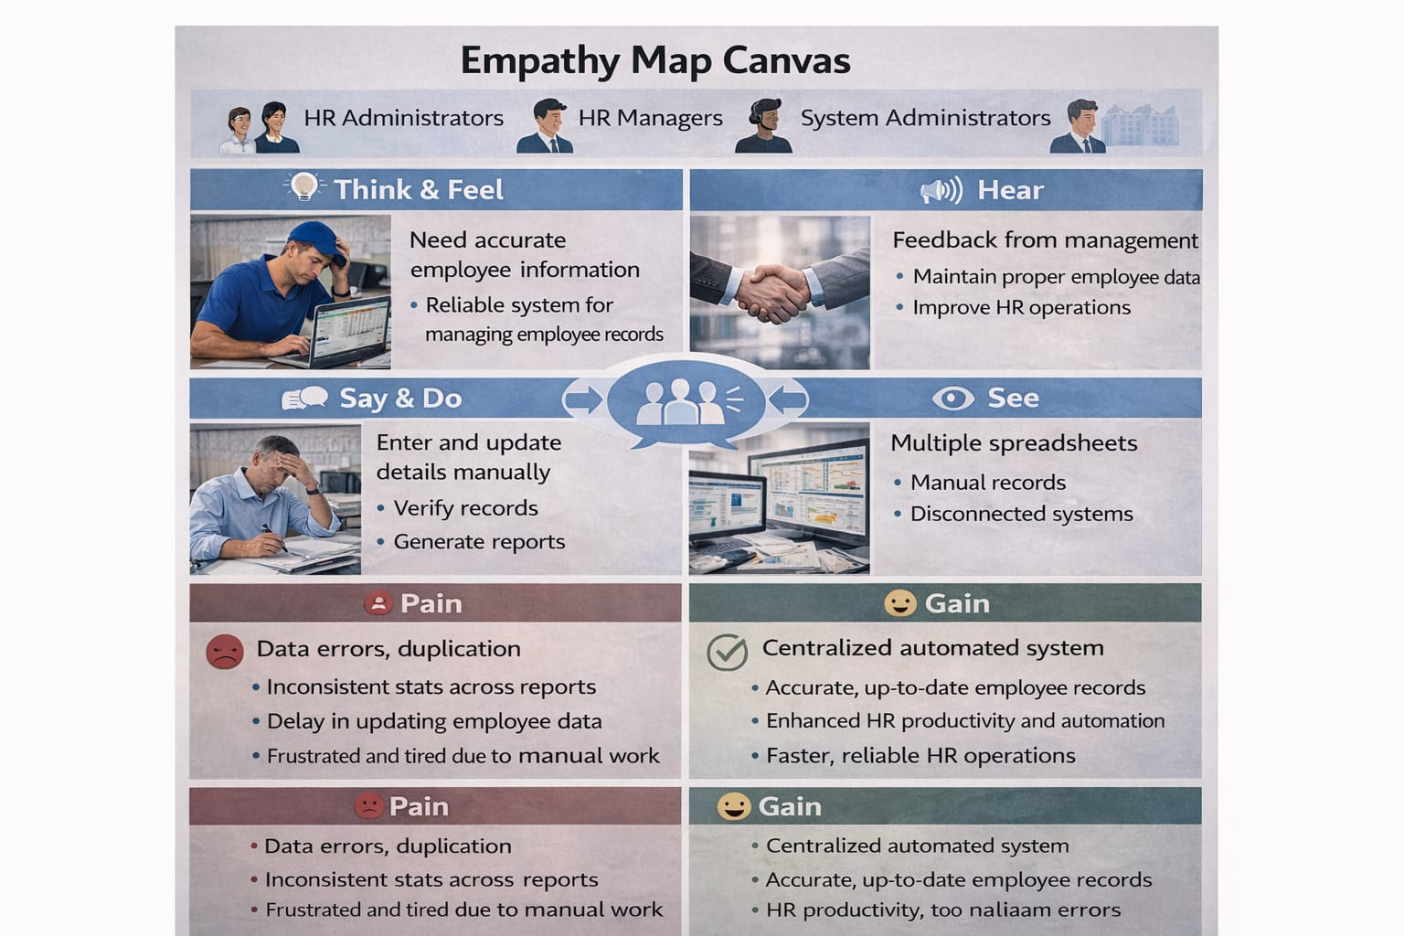
● Say & Do: Enter and update employee details manually, verify records, and generate reports when required.

2.3 Brainstorming:
Brainstormed Ideas
● Web-based employee data management system
● Mobile application for employee record tracking
● ServiceNow-integrated employee management platform
● Automated workflow system for HR operations
● Dashboard-based employee data analytics and reporting
Selected Idea:
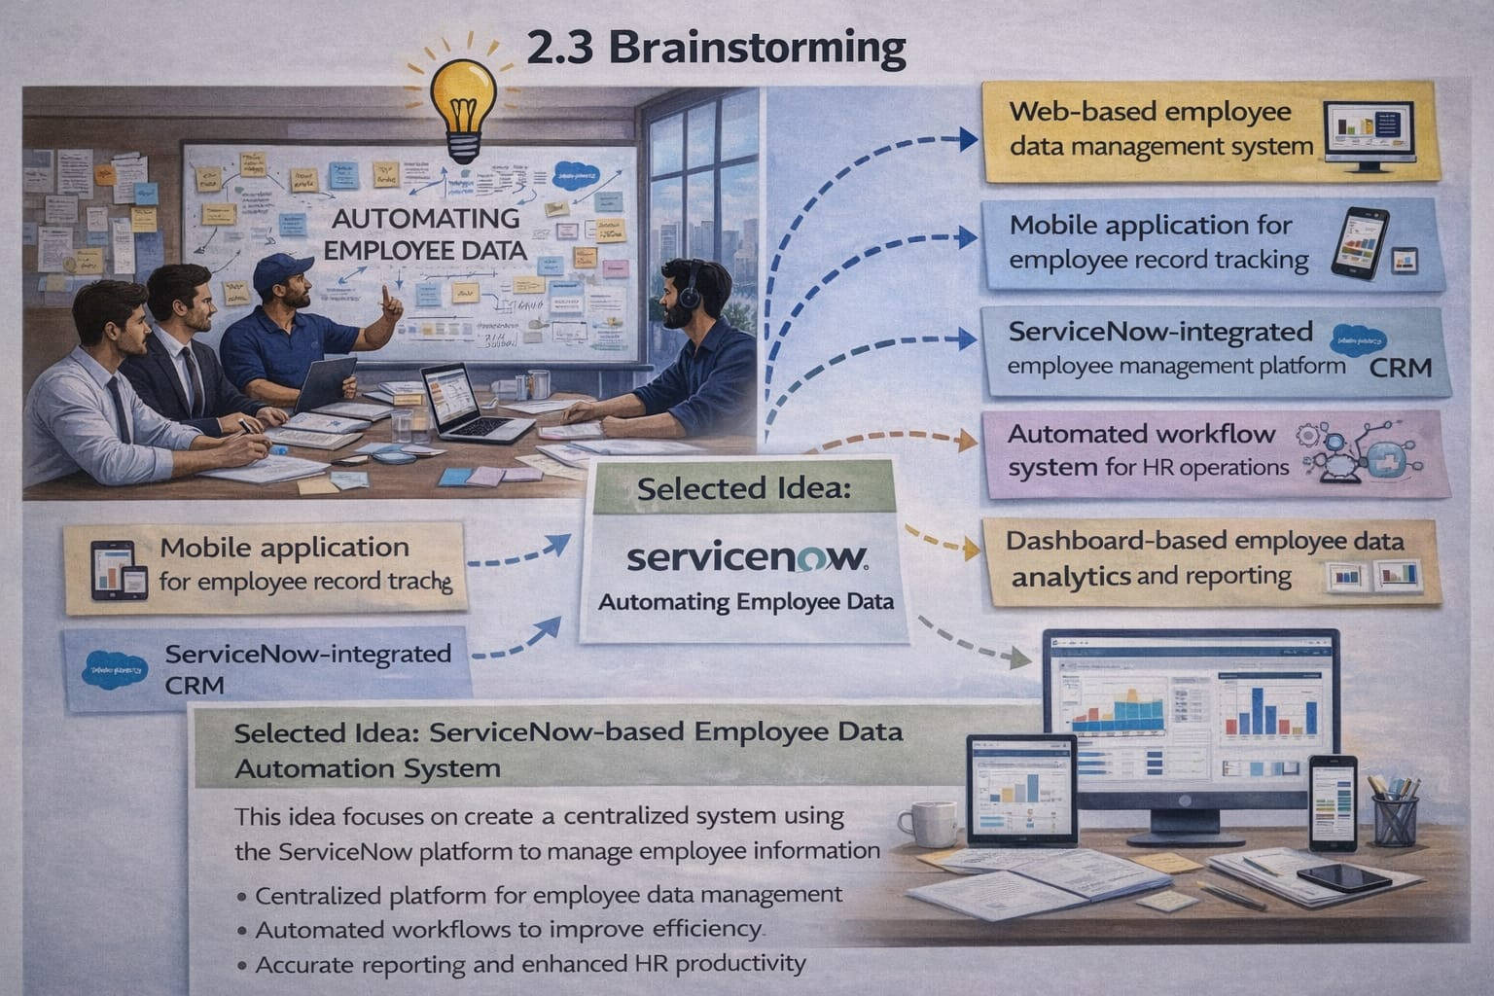
ServiceNow-based Employee Data Automation System (Automating Employee Data)

3. REQUIREMENT ANALYSIS PHASE
3.1 Customer Journey Map:
Journey Stages:
● Login to the ServiceNow system
● Add or register employee details
● Update employee information and records
● Store and manage employee data in the system
● Generate employee reports and analytics
● Review data for HR decision making

3.2 Solution Requirements:
The Automating Employee Data system requires a centralized platform that can efficiently store, manage, and update employee information. The system should provide a user-friendly interface where HR administrators can easily enter employee details such as employee ID, name, department, designation, and contact information. It should also ensure that employee data is stored securely and can be accessed only by authorized users.
The solution must include features such as automated workflows, data validation, and reporting capabilities. These features help reduce manual work and improve the accuracy of employee records. Additionally, the system should allow HR managers to quickly retrieve employee information and generate reports for decision-making purposes. By implementing these requirements using the ServiceNow platform, the organization can improve efficiency and maintain a reliable employee data management system.

3.3 Data Flow Diagram:

User → ServiceNow User Interface → Employee Table (Custom Table) → Data Validation → Business Rules / Flow Designer → Reports → Dashboards
In this system, the HR Administrator or Manager (User) logs into the ServiceNow user interface and enters employee details through forms. The information is stored in the Employee Table (custom table) created in ServiceNow. The system then performs data validation to ensure that the entered details are correct and complete. After validation, Business Rules or Flow Designer automate actions such as updating records or triggering notifications. Finally, the processed data is used to generate reports and dashboards, which help HR managers analyze employee information and support decision-making.

3.4 Technology stack:

Layer | Technology
Frontend | ServiceNow User Interface (Forms & Portal)
Database | ServiceNow Tables (Employee Data Table)
Automation | Flow Designer / Business Rules
Backend | ServiceNow Platform
Analytics | Reports & Dashboards

4. PROJECT DESIGN PHASE
4.1Project Solution Fit:
The Automating Employee Data project provides an effective solution for managing employee information within an organization. In many organizations, employee data is handled manually, which often leads to errors, duplication of records, and difficulty in accessing accurate information. This project addresses these challenges by implementing an automated system using the ServiceNow platform.
The proposed solution fits the organizational needs by providing a centralized platform where employee data can be stored, managed, and updated efficiently. The system allows HR administrators to easily add and maintain employee records while ensuring data accuracy and security. Automation features such as workflows, validation rules, and reporting tools help reduce manual effort and improve productivity. As a result, the project enhances HR operations and supports better decision-making through reliable employee data management.
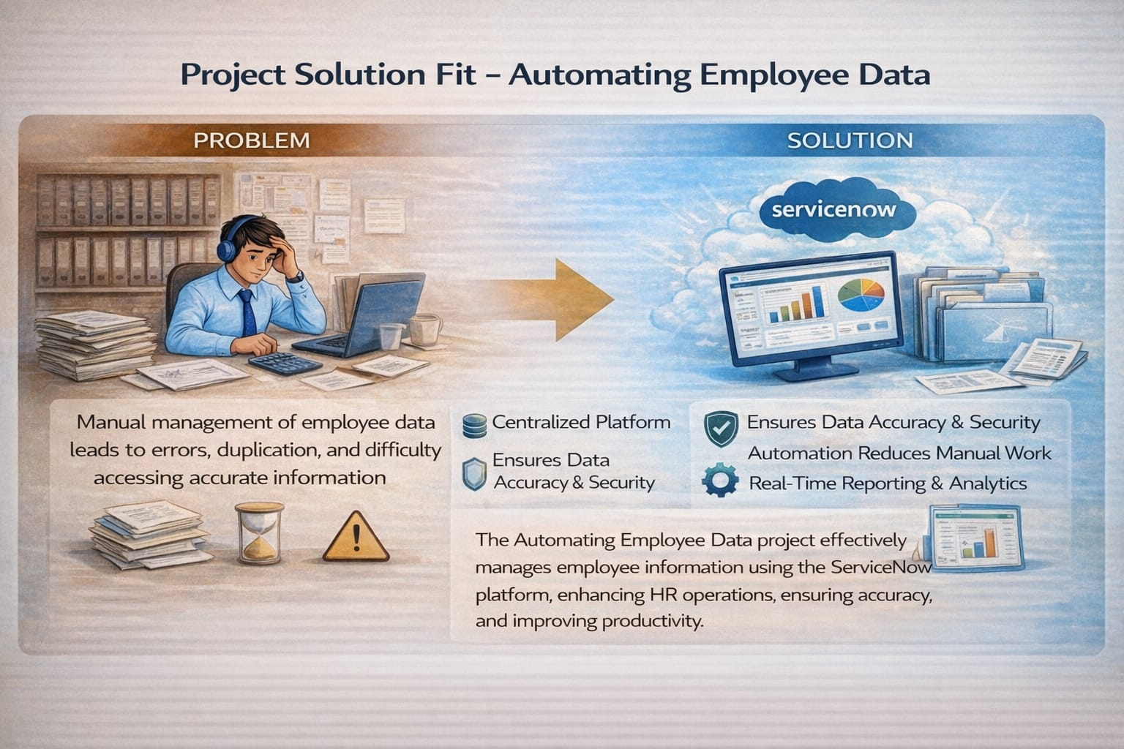

4.2Proposed Solution:
The Automating Employee Data project proposes the development of a centralized and automated system using the ServiceNow platform to manage employee information efficiently. The system allows HR administrators to add, update, and maintain employee records such as employee ID, name, department, designation, and contact details through a user-friendly interface.
The proposed solution also includes automation features such as data validation, workflow automation, and role-based access control to ensure data accuracy and security. In addition, the system provides reporting and dashboard functionalities that help HR managers analyze employee information and make better decisions. By implementing this solution, organizations can reduce manual work, improve data management, and increase the overall efficiency of HR operations.

Centralized Employee Data Management:
One of the key features of the proposed solution is centralized employee data management. All employee records will be stored in a single database, allowing administrators to access and manage the information efficiently.
This centralized approach eliminates the need for maintaining multiple files or documents. HR administrators can easily retrieve employee details such as employee ID, department, designation, and contact information. This improves the organization and accessibility of employee records.

User-Friendly Interface:
The proposed system will provide a user-friendly interface that allows administrators to interact with the system easily. The application will include forms and dashboards that simplify the process of entering and managing employee data.
Users will be able to add new employee records, update existing information, and search for employee details quickly. The interface will be designed to ensure that even users with minimal technical knowledge can operate the system effectively.

Data Validation and Accuracy:
Another important feature of the proposed solution is data validation. The system will include validation rules to ensure that the data entered by users is accurate and complete.
For example, fields such as employee ID, phone number, and email address will follow specific formats. This reduces the chances of incorrect data entry and ensures that employee records remain reliable and consistent.
Security and Access Control:
The proposed system will also focus on maintaining the security of employee information. Since employee data contains sensitive details, it is important to ensure that only authorized users can access or modify the records.
The system will implement role-based access control, which allows administrators to define permissions for different users. This ensures that employee data remains protected from unauthorized access.

Reporting and Data Analysis:
The system will include reporting features that allow administrators to generate reports based on employee data. These reports can provide insights into employee distribution across departments, job roles, and other relevant information.
Reports help managers analyze workforce data and support better decision-making within the organization. The reporting functionality also helps maintain transparency and improve HR management.

Scalability and Future Improvements:
The proposed solution is designed to be scalable so that it can support future enhancements. As the organization grows, the system can be expanded to include additional features such as leave management, attendance tracking, and payroll integration.
This flexibility ensures that the system can adapt to changing organizational requirements and continue to support efficient employee data management.

4.3Solution Architecture:
The solution architecture of the Automating Employee Data system is designed to provide a structured and efficient way to manage employee information within an organization. The system is built using the ServiceNow platform, which allows organizations to automate HR processes and maintain employee records in a centralized environment. The architecture mainly includes the user interface layer, application logic layer, and data storage layer.
In the user interface layer, HR administrators and managers interact with the system through ServiceNow forms and dashboards. This interface allows users to easily enter, update, and view employee details such as employee ID, name, department, designation, and contact information. The user-friendly interface helps reduce complexity and allows HR staff to manage employee records efficiently without requiring advanced technical knowledge.
The application logic layer handles the processing and automation of employee data. This layer includes ServiceNow features such as business rules, flow designer, and validation mechanisms. These components ensure that the data entered into the system is accurate and complete. Automation workflows can trigger notifications, update records automatically, and ensure that the required HR processes are followed properly.
The data storage layer consists of custom ServiceNow tables that store employee information securely. These tables maintain structured records of employee data and allow the system to retrieve information quickly when required. The stored data can be used to generate reports and dashboards, which provide valuable insights for HR managers and organizational leaders.

5.PROJECT PLANNING AND SCHEDULING
Project planning and scheduling is a crucial phase in the development of the Automating Employee Data system. This phase focuses on organizing all project activities in a structured manner to ensure that the project is completed successfully within the specified time frame. Proper planning helps identify the tasks required for the project, allocate responsibilities, and ensure that all resources are used effectively during the development process.
During the planning stage, the project objectives, scope, and requirements are clearly defined. The development team analyzes the requirements and prepares a detailed plan for implementing the system using the ServiceNow platform. The planning process includes identifying the necessary modules such as employee data entry, employee record management, workflow automation, and reporting features. Each module is designed to support the overall goal of improving employee data management within the organization.
Project scheduling involves dividing the entire project into different phases such as requirement analysis, system design, development, testing, and implementation. Each phase is assigned a specific time period and set of tasks that must be completed before moving to the next stage. This structured approach ensures that the project progresses smoothly without delays or confusion.
In the development phase, tasks such as creating ServiceNow tables, designing forms, configuring business rules, and implementing flow designer automation are scheduled and executed systematically. After development, the system is tested to verify that employee data can be entered, stored, and retrieved correctly. Testing also ensures that automation processes such as notifications and workflows function as expected.
Finally, the implementation phase focuses on deploying the system for actual use by HR administrators and managers. Once the system is deployed, users can efficiently manage employee records, update information, and generate reports when needed. Through proper project planning and scheduling, the Automating Employee Data system can be developed in a well-organized manner, ensuring improved productivity and efficient management of employee information.

5.1 Project Objectives:
The main objective of the Automating Employee Data project is to develop a system that simplifies the process of managing employee information within an organization. The system aims to provide a centralized platform where HR administrators can easily store, update, and retrieve employee records.
Another objective of the project is to reduce manual work and improve efficiency in HR operations. By automating employee data management, the system ensures that employee information is maintained accurately and securely.

5.2 Project scope:
The scope of the project defines the boundaries and functionalities of the system. The Automating Employee Data system focuses on managing essential employee information such as employee name, employee ID, department, designation, and contact details.
The system allows administrators to add new employee records, update existing information, and view employee details when required. The project scope mainly focuses on employee data management and reporting features. Additional features such as leave management and attendance tracking can be added in the future.

5.3 Project Planning Process:
The project planning process includes identifying the steps required to complete the project successfully. The planning phase begins with requirement analysis, where the development team gathers information about the system requirements.
After understanding the requirements, the team designs the system architecture and database structure. The next step involves developing the application using the ServiceNow platform. Once the development phase is completed, the system is tested to ensure that it functions correctly. Finally, the system is deployed and documented.

5.4 Work Breakdown Structure (WBS):
The Work Breakdown Structure is a project management technique used to divide the project into smaller and manageable tasks. Breaking the project into smaller activities makes it easier to plan and monitor progress.
The Work Breakdown Structure for the Automating Employee Data project includes the following tasks:
- Requirement Analysis
- System Design
- Database Creation
- Application Development
- Testing and Debugging
- Deployment
- Documentation
Each task is completed step by step to ensure that the project is developed successfully.

5.5 Project Scheduling:
Project scheduling involves creating a timeline for completing different project activities. A schedule helps the development team manage time effectively and ensures that each phase of the project is completed within the planned duration.
In this project, the schedule was organized into different phases such as requirement analysis, system design, development, testing, and deployment. By following this schedule, the development team was able to track the progress of the project and complete tasks within the specified timeframe.

5.6 Resource Planning:
Resource planning involves identifying the resources required for project development. These resources include human resources, software tools, and technical infrastructure.
For the Automating Employee Data project, the main resources include the ServiceNow platform, development tools, and the project team responsible for designing and implementing the system. Proper resource planning ensures that all necessary tools and personnel are available during each stage of the project.

5.7 Risk Management:
Risk management is an important aspect of project planning. It involves identifying potential risks that may affect the progress of the project and taking steps to minimize their impact.
Possible risks in the Automating Employee Data project include technical difficulties, delays in development, and data security issues. By identifying these risks early, the development team can take preventive measures and ensure that the project is completed successfully.

5.8 Project Monitoring and Control:
Project monitoring and control ensure that the project progresses according to the planned schedule. During the development process, the project team continuously monitors project activities and compares them with the planned timeline.
If any issues or delays are identified, corrective actions are taken to keep the project on track. Monitoring also helps maintain quality standards and ensures that the final system meets the project requirements.

6. PROJECT DEVELOPMENT
The Project Development Phase is an important stage in the Automating Employee Data system. In this phase, the application is developed using the ServiceNow platform. The main goal of this phase is to implement the planned system design and develop a working application that can store and manage employee information effectively. The development process includes creating the ServiceNow application, designing employee data tables, building forms, and implementing automation features.
During this phase, different components of the system are created and integrated to ensure that the application works efficiently. The ServiceNow platform provides various tools that help in developing and automating the employee data management process.
6.1 ServiceNow Developer Instance Creation:
The first step in the project development phase is creating a ServiceNow developer instance. The developer instance provides a cloud-based environment where developers can build and test their applications. By registering on the ServiceNow developer portal, a personal instance can be created for development purposes.
This instance allows developers to access ServiceNow features such as application creation, database tables, form design, and automation tools. The developer instance acts as the main platform where the Automating Employee Data application is developed and tested before deployment.

6.2 Application Creation:
After creating the developer instance, a custom application is created within the ServiceNow platform. The application serves as a container that holds all the components related to the employee data management system.
The application includes modules such as employee data entry, employee record management, workflow automation, and reporting. By creating a separate application, all project-related elements can be organized and managed efficiently within the ServiceNow environment.

6.3 Employee Table Creation:
A custom employee table is created in ServiceNow to store employee information. This table acts as the database for the application. It contains different fields that hold employee details such as employee ID, employee name, department, designation, email address, and phone number.
The employee table helps store structured data and ensures that employee records are organized properly. HR administrators can easily add, update, and retrieve employee records from this table whenever required.

6.4 Form Design:
Forms are designed to allow users to enter employee data into the system. The ServiceNow form interface provides a user-friendly way to input and manage employee information. HR administrators can use these forms to add new employee records or update existing records.
The form layout is designed in such a way that all important employee details are clearly displayed. This helps ensure that the data entered into the system is complete and properly organized.

6.5 Automation Using Business Rules and Flow Designer:
Automation plays a key role in improving the efficiency of the system. ServiceNow provides automation tools such as Business Rules and Flow Designer to automate different tasks in the application.
For example, when a new employee record is created, the system can automatically trigger a workflow or send notifications to relevant users. Business rules can also validate data and ensure that correct information is entered into the system.

6.6 Reports and Dashboards:
Reports and dashboards are created to analyze employee data effectively. Reports help HR managers view employee records, department details, and other important information in a structured format.
Dashboards provide a visual representation of employee data using charts and graphs. These dashboards allow managers to quickly understand employee information and make better decisions based on the available data.

7. TESTING PHASE
The Testing Phase is an important stage in the development of the Automating Employee Data system. In this phase, the developed application is tested to ensure that all the features and functionalities are working correctly. Testing helps identify errors, bugs, and system issues before the application is deployed for actual use.
The main objective of testing is to verify that the system performs according to the specified requirements. It ensures that employee data can be entered, stored, updated, and retrieved without any errors. Proper testing improves the reliability, performance, and efficiency of the system.
During this phase, different testing methods are used to check the performance and accuracy of the application. These tests help confirm that the ServiceNow application is functioning properly and meeting the project objectives.
7.1 Test Plan:
The test plan defines the strategy used to test the Automating Employee Data system. It describes the testing process, testing environment, and expected results. The test plan ensures that all modules of the system are tested systematically.
The testing process includes verifying the employee data entry form, employee record storage, data update functionality, and report generation features. The goal is to confirm that each function works correctly and produces the expected results.

7.2 Test Cases:
Test cases are used to verify whether the system functions correctly under different conditions. Each test case checks a specific function of the application.
Example test cases include adding a new employee record, updating existing employee information, deleting employee records, and generating reports. These tests ensure that the system handles data correctly and performs the required operations successfully.

7.3 Functional Testing:
Functional testing ensures that all features of the Automating Employee Data system work according to the requirements. This type of testing focuses on verifying system functionalities such as employee data entry, data storage, data retrieval, and automation processes.
texisting data, and retrieve information without any issues. Functional testing ensures that the application behaves as expected.

7.4 Performance Testing:
Performance testing is conducted to evaluate how the system performs under different conditions. This testing ensures that the application responds quickly when users access employee data or generate reports.
The system should be able to handle multiple employee records without slowing down. Performance testing helps ensure that the application provides a smooth and efficient user experience.

7.5 System Validation:
System validation ensures that the developed system meets the project requirements and objectives. This process confirms that the Automating Employee Data application works correctly within the ServiceNow platform.
After completing the testing process, the system is verified and approved for implementation. This ensures that HR administrators can use the application to manage employee records efficiently without any technical issues.

8. IMPLEMENTATION PHASE
The Implementation Phase is the stage where the developed Automating Employee Data system is deployed for actual use within the organization. After completing the development and testing phases, the system is implemented in the ServiceNow platform so that HR administrators and managers can start using it to manage employee information efficiently.
During this phase, the developed application is configured and integrated within the ServiceNow environment. The system is prepared to store employee data such as employee ID, employee name, department, designation, email, and contact information. Proper implementation ensures that the application works smoothly and meets the requirements of the organization.
The implementation process also includes verifying that all modules of the system are functioning correctly in the real environment. HR administrators are given access to the application so that they can add, update, and manage employee records easily. This phase ensures that the system is ready for practical use and helps improve the efficiency of employee data management.

8.1 System Deployment:
System deployment refers to the process of making the developed application available for use in the ServiceNow environment. The Automating Employee Data system is deployed within the ServiceNow platform so that authorized users can access it through the ServiceNow interface.
Once the system is deployed, HR administrators can start entering employee data into the application. The deployment process ensures that the system is properly configured and connected with the required ServiceNow components such as tables, forms, workflows, and reports.

8.2 User Training:
After deploying the system, user training is provided to ensure that HR administrators and managers understand how to use the application effectively. Training helps users learn how to enter employee data, update records, and generate reports.
Proper training ensures that users can operate the system without difficulties and take full advantage of the automation features provided by the application.

8.3 System Maintenance:
System maintenance is an important activity that ensures the application continues to function properly after implementation. Maintenance includes monitoring system performance, updating features, and fixing any issues that may arise.
Regular maintenance helps ensure that the Automating Employee Data system remains reliable and efficient in managing employee information within the organization.

9. RESULTS AND DISCUSSION
The Results and Discussion section explains the outcome of the Automating Employee Data system after its development and implementation. The system was successfully developed using the ServiceNow platform to manage employee information efficiently. The application allows HR administrators to enter, store, update, and retrieve employee data through a centralized system.
After implementing the system, it was observed that the process of managing employee records became faster and more organized. The user-friendly interface allows HR staff to easily enter employee details such as employee ID, name, department, designation, email, and contact number. The automation features implemented through ServiceNow help reduce manual work and ensure that employee data is stored accurately.
The system also provides reporting and dashboard features that help managers analyze employee information. Reports generated by the system allow HR managers to monitor employee records and obtain important insights when required. These reports help improve decision-making within the organization.
Overall, the Automating Employee Data system improves the efficiency of employee data management. It reduces the chances of data errors, eliminates the need for manual record keeping, and provides a reliable platform for storing and accessing employee information.

10. ADVANTAGES OF THE SYSTEM
The Automating Employee Data system provides many advantages for organizations that need an efficient way to manage employee information. In traditional systems, employee records are often stored manually in files or spreadsheets, which can lead to errors, duplication, and data loss. By implementing an automated system using the ServiceNow platform, organizations can improve the accuracy, security, and accessibility of employee data. This system helps HR departments manage employee information more effectively and reduces the time required for administrative tasks.

10.1 Improved Data Management:
One of the main advantages of the Automating Employee Data system is improved data management. In many organizations, employee data is stored in multiple files or documents, which makes it difficult to track and maintain. This system stores all employee information in a centralized database, allowing administrators to easily manage and update records.
With a centralized system, HR personnel can quickly search for employee details such as name, department, designation, contact information, and employment status. This eliminates the need to manually check different records and improves the overall efficiency of the organization. The system also allows easy modification of records whenever there is a change in employee details.

10.2 Reduction of Manual Work:
Another major advantage of the system is the reduction of manual work. Traditional employee data management often involves writing or updating information manually in files or spreadsheets. This process is time-consuming and increases the possibility of human errors.
By automating the process, the system allows HR administrators to enter employee data through digital forms. The information is automatically stored in the database and can be accessed whenever needed. Automation helps organizations save time and resources while improving productivity.

10.3 Improved Data Accuracy:
Data accuracy is very important in employee management systems. Incorrect or outdated information can cause problems in organizational processes. The Automating Employee Data system includes validation features that ensure the accuracy of the information entered into the system.
For example, the system can validate fields such as email address, employee ID, and contact number. This reduces the chances of entering incorrect data. In addition, administrators can update records easily, ensuring that employee information remains accurate and up to date.

10.4 Easy Access to Information:
The system provides easy access to employee information for authorized users. Instead of searching through physical files or documents, HR administrators can retrieve employee details instantly using the system interface.
This feature helps managers and HR staff quickly access the information they need for decision-making. For example, when preparing reports or reviewing employee records, the system allows users to find the required data within seconds. This improves the speed and efficiency of HR operations.

10.5 Enhanced Data Security:
Security is another important advantage of the Automating Employee Data system. Employee information contains sensitive details such as personal information, contact details, and job-related data. Protecting this information is very important for any organization.
The ServiceNow platform provides role-based access control, which ensures that only authorized users can access or modify employee records. This prevents unauthorized access and protects confidential data. In addition, the system maintains a secure database where employee records are safely stored.

10.6 Report Generation and Analytics:
The system also provides features for generating reports and analyzing employee data. HR administrators can create reports based on different parameters such as department, designation, or employee status. These reports help organizations understand workforce distribution and make better management decisions.
For example, managers can use reports to identify the number of employees in each department or track changes in employee records over time. This analytical capability supports strategic planning and improves organizational efficiency.

10.7 Time Efficiency:
Automation significantly improves time efficiency in managing employee data. Tasks that previously required manual effort can now be completed quickly using the system. HR administrators can add, update, or retrieve employee information within a few seconds.
This allows HR departments to focus on more important activities such as employee engagement and organizational development rather than spending time on routine administrative tasks.

10.8 Scalability and Flexibility:
Another advantage of the system is its scalability and flexibility. As an organization grows, the number of employees and the amount of data also increase. The Automating Employee Data system can handle large volumes of data without affecting performance.
The system can also be customized according to the needs of the organization. New fields, modules, or workflows can be added to support additional HR processes. This flexibility makes the system suitable for organizations of different sizes.

11. FUTURE ENHANCEMENT
The Automating Employee Data system has been developed to simplify the process of managing employee information within an organization. Although the current system provides essential features such as storing, updating, and managing employee records, there are several opportunities for improving the system in the future. By adding more advanced features and integrating additional modules, the system can become more powerful and efficient.
Future enhancements will help organizations manage not only employee data but also other HR-related processes such as attendance, payroll, leave management, and performance tracking. These improvements will increase the overall efficiency of the system and provide better support for organizational decision-making.

11.1 Integration with Attendance Management:
One possible future enhancement is the integration of an attendance management system. Currently, the system focuses mainly on employee data storage and management. By adding attendance tracking, organizations can monitor employee attendance records directly within the system.
This feature would allow HR administrators to track daily attendance, late arrivals, and absences. It would also help managers analyze attendance patterns and ensure that employees maintain regular working hours. Integrating attendance data with employee records would make the system more comprehensive and useful.

11.2 Leave Management System:
Another important future enhancement is the addition of a leave management module. In many organizations, employees apply for leave manually or through separate systems. By integrating leave management into the Automating Employee Data system, employees will be able to submit leave requests directly through the platform.
Managers can review and approve or reject leave requests easily. The system can automatically update the leave balance and maintain a record of all leave transactions. This feature will simplify the leave approval process and reduce administrative work for HR departments.

11.3 Payroll Integration:
Payroll management is an important function in any organization. In the future, the system can be enhanced by integrating payroll management features. This will allow HR administrators to manage employee salary information, allowances, and deductions within the same platform.
With payroll integration, the system can automatically generate salary reports and maintain accurate payment records. This will reduce the need for separate payroll systems and ensure that employee data is consistent across different processes.

11.4 Performance Management Module:
Another potential enhancement is the addition of a performance management module. Organizations often evaluate employee performance to measure productivity and identify areas for improvement. By adding this feature, managers can record performance reviews and track employee achievements.
The system can include features such as performance ratings, feedback from managers, and goal tracking. This will help organizations monitor employee development and support career growth within the company.

11.5 Mobile Application Support:
In the future, the system can be enhanced by developing a mobile application. A mobile app would allow HR administrators and managers to access employee data from their smartphones or tablets. This would make the system more convenient and accessible.
Employees could also use the mobile application to view their information, apply for leave, or update certain details. Mobile support would improve the usability of the system and allow users to access important information anytime and anywhere.

11.6 Advanced Reporting and Analytics:
Another future enhancement is the development of advanced reporting and analytics features. While the current system can generate basic reports, future versions could include more detailed analytical tools.
These tools could help organizations analyze workforce trends, employee distribution across departments, and other important HR metrics. Visual dashboards and charts could be added to provide better insights into employee data. This will support better decision-making for management.

11.7 System Integration with Other Platforms:
The system can also be enhanced by integrating it with other organizational platforms such as recruitment systems, training management systems, and communication tools. This integration will allow data to be shared across different systems without manual input.
For example, when a new employee is recruited through a recruitment platform, their information can automatically be added to the employee data system. This will improve efficiency and reduce duplicate data entry.

11.8 Improved Security Features:
Security is very important when managing employee data. Future versions of the system can include additional security features such as multi-factor authentication, stronger access controls, and data encryption.
These features will ensure that employee information remains protected and accessible only to authorized users. Improved security will increase trust in the system and protect sensitive organizational data

12. CONCLUSION
The Automating Employee Data project was developed with the aim of improving the efficiency of managing employee information within an organization. In many organizations, employee data is often maintained manually using physical files or spreadsheets. This traditional method is time-consuming and can lead to errors, duplication, and difficulty in accessing information. The implementation of an automated system helps overcome these challenges by providing a structured and digital platform for managing employee records.
The system developed using the ServiceNow platform allows HR administrators to easily store, update, and retrieve employee information. Through the use of forms, tables, and automated workflows, the application simplifies the process of employee data management. It reduces the need for manual record keeping and ensures that employee information is stored in a centralized and organized database.
One of the main achievements of this project is the improvement in data accessibility and accuracy. Authorized users can quickly access employee information whenever required, which improves the efficiency of HR operations. The system also includes validation mechanisms that help ensure the correctness of the data entered into the system. This reduces the chances of human errors and improves the reliability of the employee records.
Another important benefit of the system is automation. By automating routine tasks such as data entry and record updates, the system reduces administrative workload and allows HR personnel to focus on more important tasks such as employee development and organizational planning. Automation also helps maintain consistency in the management of employee information.
The project also demonstrates the importance of digital transformation in human resource management. As organizations grow, managing employee data manually becomes increasingly difficult. Implementing automated systems like the Automating Employee Data application helps organizations handle large amounts of employee information efficiently while maintaining accuracy and security.
Although the current system focuses mainly on basic employee data management, it provides a strong foundation for future improvements. Additional modules such as attendance tracking, leave management, payroll integration, and performance evaluation can be added in the future to make the system more comprehensive. These enhancements will further increase the usefulness of the system and provide greater support for HR management.
In conclusion, the Automating Employee Data system provides an effective solution for managing employee records in a modern organizational environment. The project demonstrates how automation and digital platforms can simplify administrative processes, improve data management, and enhance overall organizational efficiency. By implementing such systems, organizations can ensure that employee information is managed in a secure, organized, and efficient manner.

